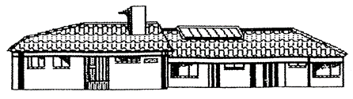

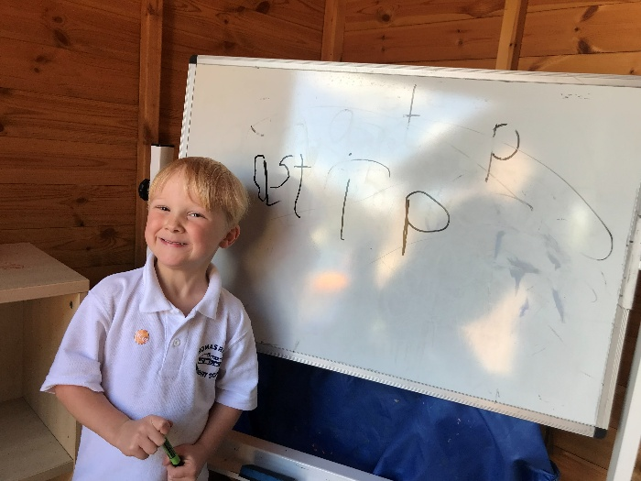

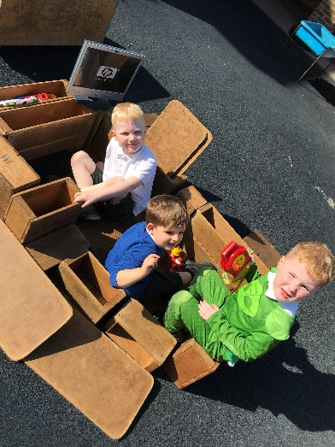
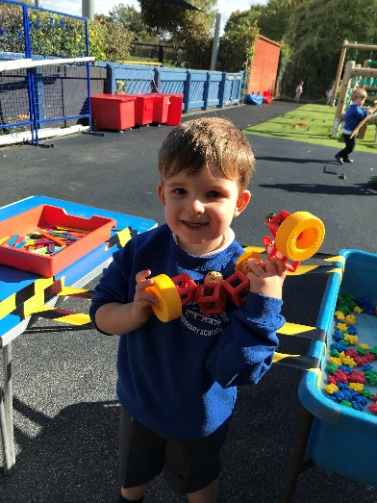

THOMAS READE
RECEPTION CLASS
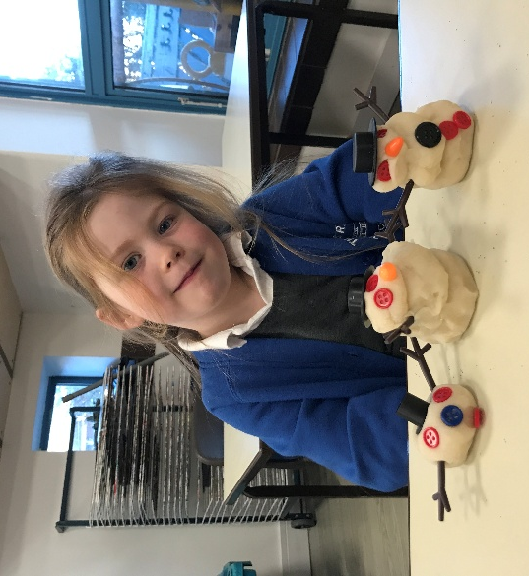
SEPTEMBER 2026

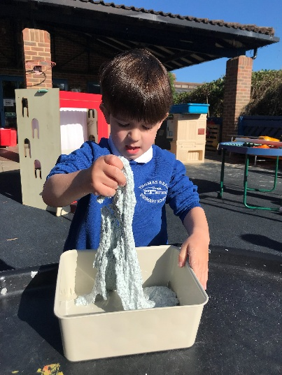
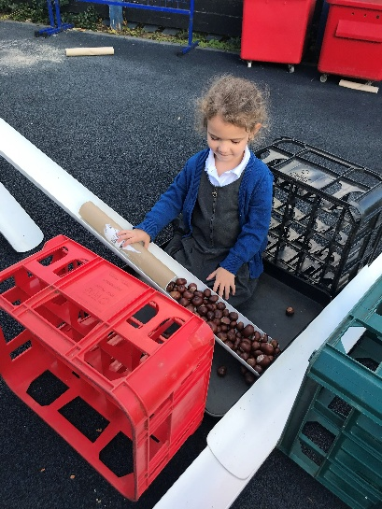

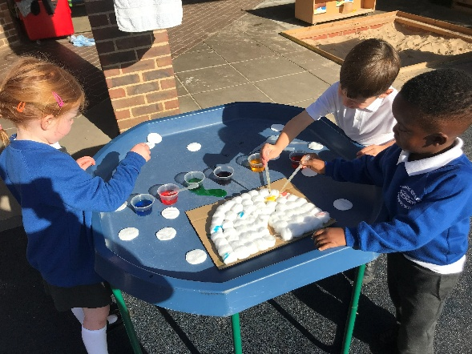

Welcome to Thomas Reade!
Thomas Reade primary school has a warm, welcoming and friendly atmosphere where children, teachers and parents work together to provide the best possible education for all children.

Although the Reception class has its own purpose built facility and wonderful outdoor space, we join in with many of the whole school events and activities such as whole school singing and celebration assemblies, Remembrance Day, World Book Day, Thomas Reade’s talent show, charity events, and sports day.

Please visit our website at www.thomasreadeschool.org to find key information such as policies, school lunch menu, and term dates.

Reception class
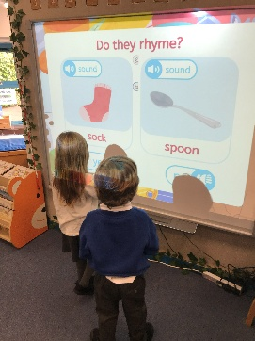
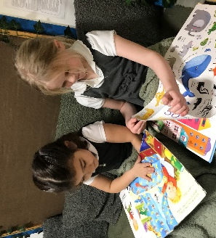
Our Reception class are lucky to have a spacious indoor classroom and outside there is a covered play area and a large, enclosed garden. Children in Reception class will take part in whole class sessions which focus on phonics, maths, understanding the world, communication and language, personal and social development and singing and story times. The open-plan room is divided into several special-purpose areas which the children can access freely during learning through play.
These are:
- a cosy reading area
- a home corner for role play
- a creative area for cutting/sticking/making
- a construction area
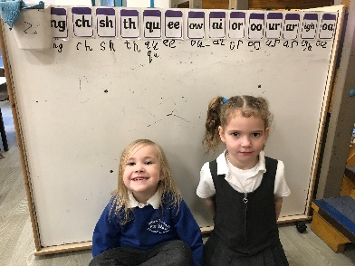
- a mark making/writing area
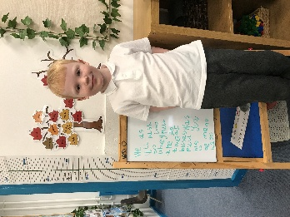
- a large whiteboard for writing/drawing
- a playdough area
- a maths area
- a small world area
- a painting easel and painting station
- junk modelling area
- a funky fingers area (where children can complete activities which develop their fine motor control and strengthen the muscles in their fingers)
- a carpet area with a smart board for whole class teaching sessions/story times
- drinking station – where children can help themselves to milk or water during the day
We also have a smaller room which is used for small group activities with an adult.
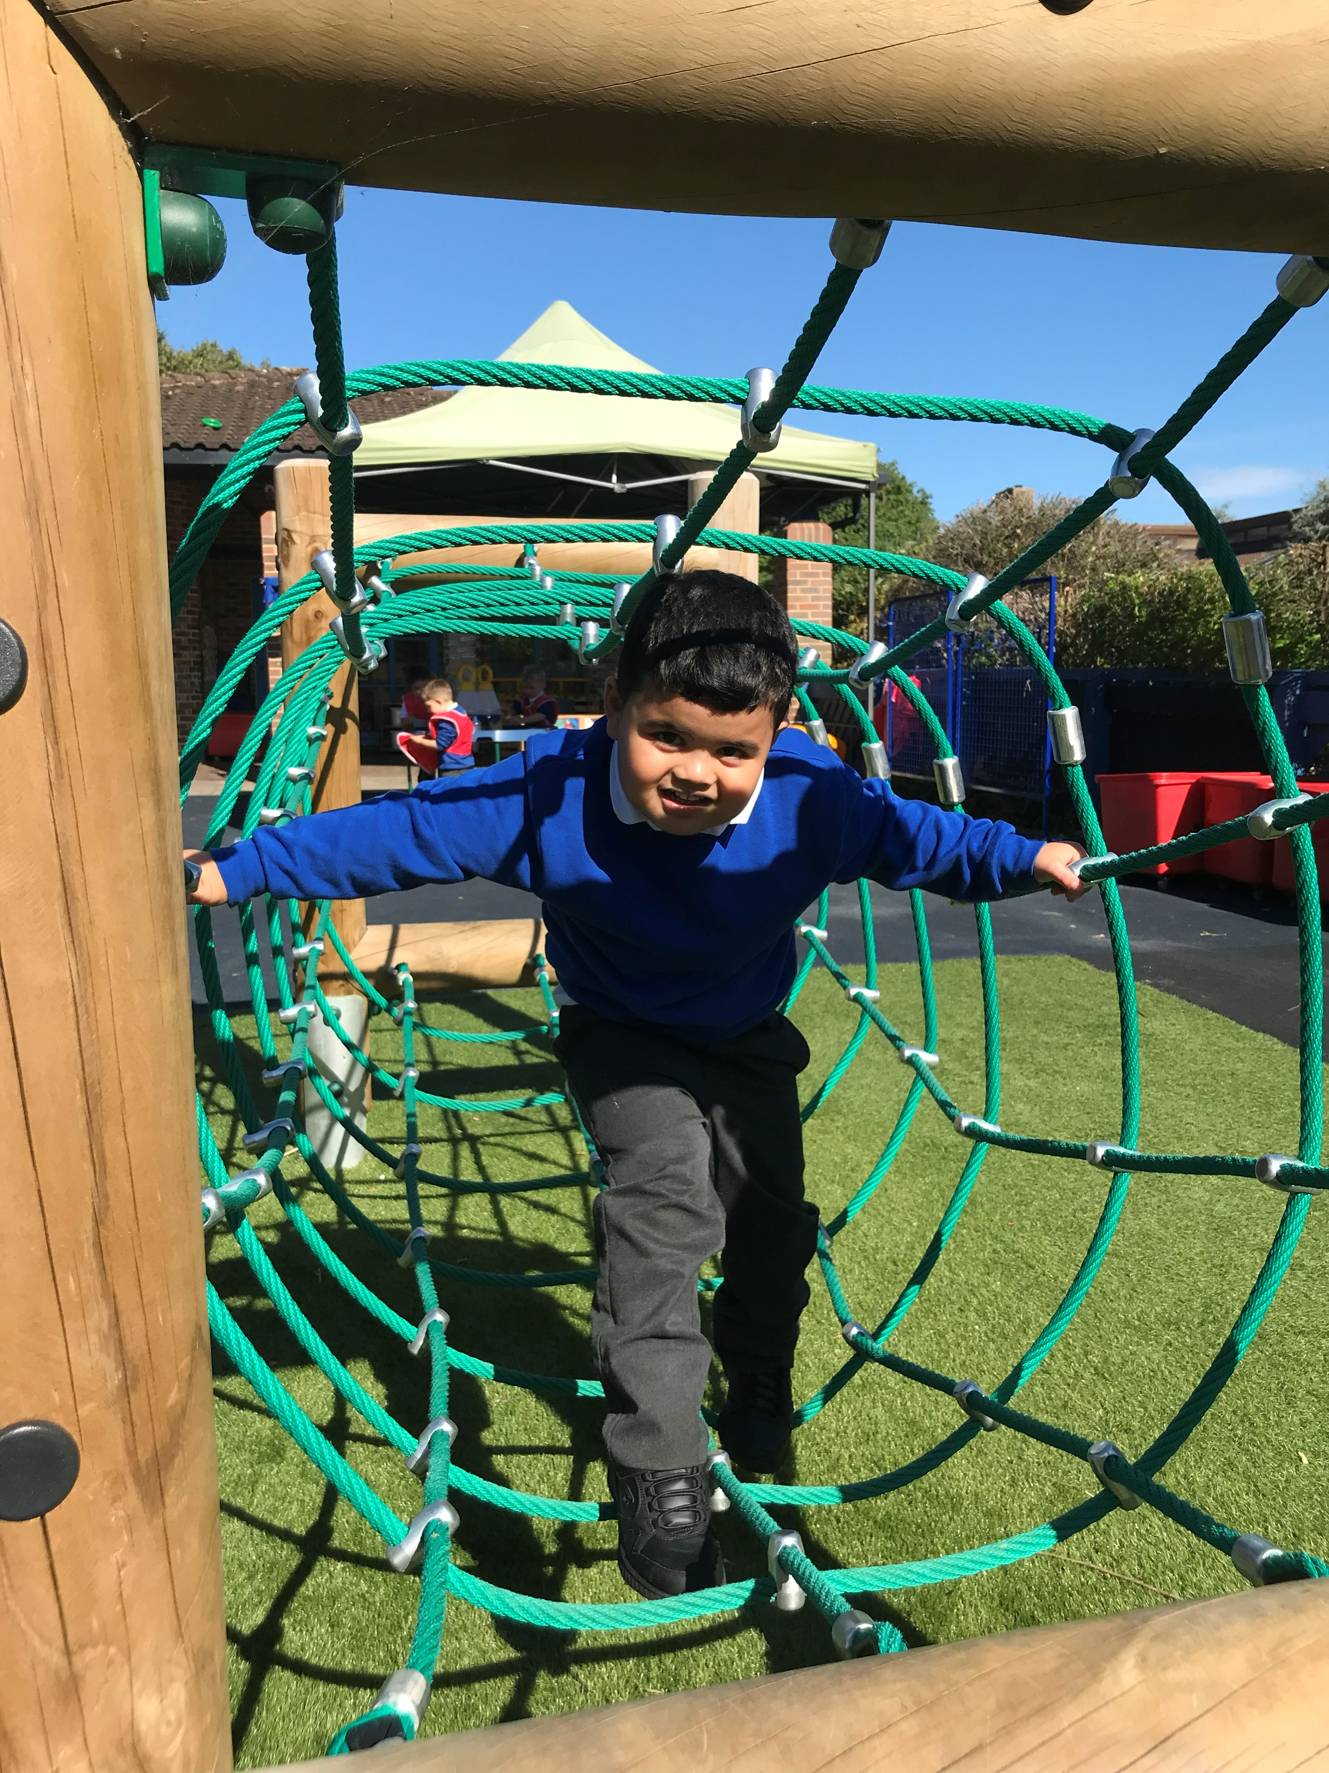
We place great emphasis on our large outdoor area, where the children’s learning is enriched by a wide range of equipment and facilities such as:
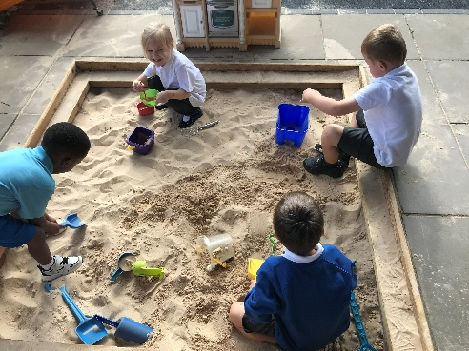
- a brand new trim trail
- large covered sandpit
- climbing frames and slide
- water trays
- water wall with pipes
- balance bikes and scooters
- hoops, tyres and balls
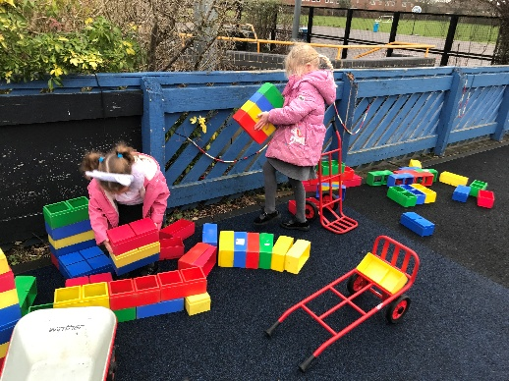
- dressing-up clothes
- large wooden bricks/construction toys
- prams, pushchairs and trolleys
- covered outside writing areas
- wooden playhouse
- large crates and planks for open ended play
- large chalkboard
- a mud kitchen
- multiple tuff trays for a wide variety of activities
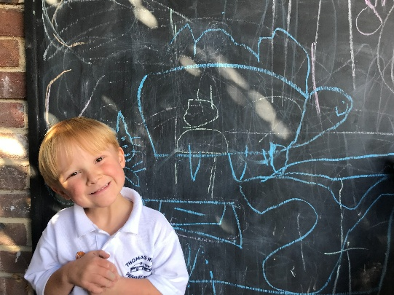
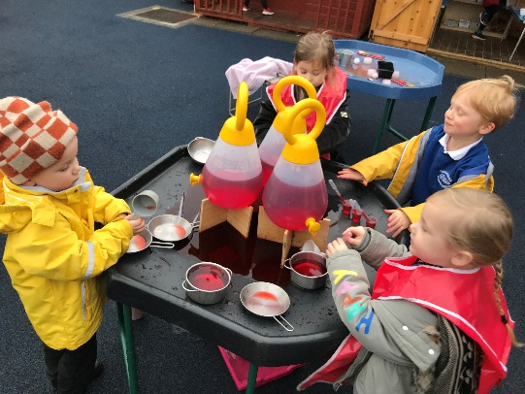

The children also take part in Forest School sessions during the summer term. Our Forest School area is a beautiful, well-resourced area in our school grounds where children can build dens, explore minibeasts and climb trees (with adult supervision). They can also spend time in the mud kitchen, the digging area or complete the additional adult led tasks.
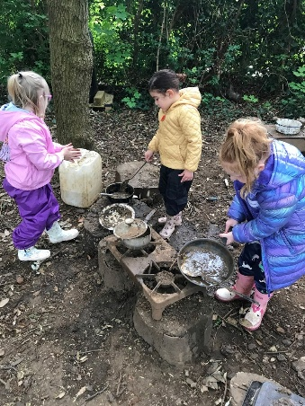
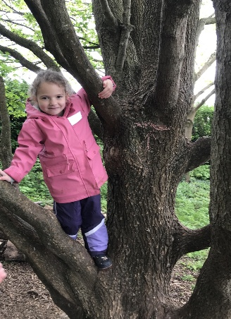
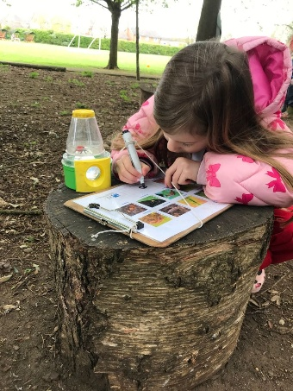
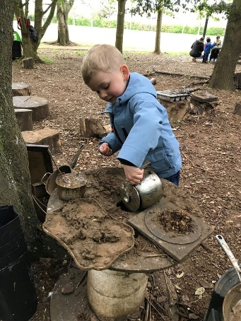

Expectations of our class:
We aim for all children to have fun learning at school and we will help them on their way to becoming independent learners. Please do not worry about getting your child ‘school ready’ in an academic sense. We will cover everything your child needs in their first year of school through a progressive and well-planned curriculum. To help your child’s preparation for school in September, we really would appreciate your help in working on/ensuring they can do the following things:
- Self-care and independence:
- Wash and dry their hands
- Put on and take off their shoes and coats independently (with the exception of zips!)
- Use the toilet completely independently
- Use cutlery
- Identify when they are hungry, thirsty, hot or cold and manage these needs
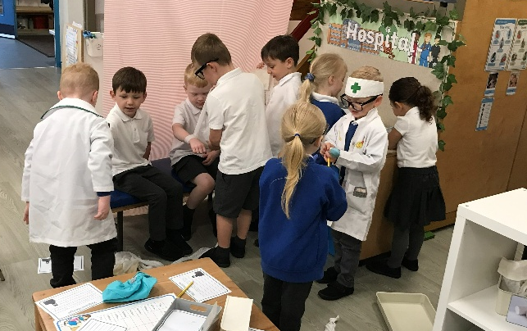
independently

- Playing with others:
- Join in games with others
- Share and take turns
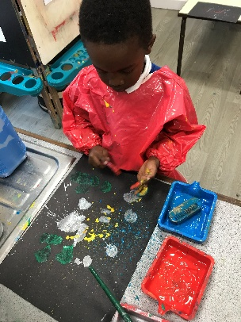
- Listen to others when they are talking

- Speaking and Listening:
- Ask a grown up for help
- Follow simple instructions
- Talk about their needs, ideas and feelings

- Literacy:
- Recognise their own name (and begin to write this correctly using a capital letter
followed by lower case letters) e.g. Molly, Bob, Nico, Romesh, Peter etc. Please do
not teach your child to write their whole name in capital letters!
- Enjoy listening to stories
- Hold a pencil (please google ‘tripod grip’ and encourage any colouring/mark making
to be done using this grip – the earlier this grip can become the natural way your

child picks up a pen/pencil the better as it is
really hard to change from a less effective grip
to this one once habits are formed)

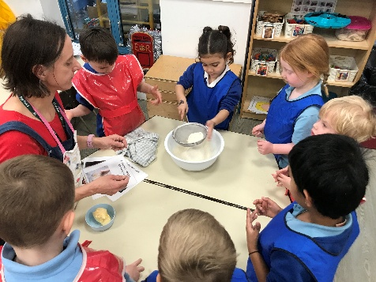
Highlights of last year/previous years:
- Becoming motivated and independent learners
- Having frogspawn in the classroom
- Visiting Abingdon library
- Enjoying books in our reading area
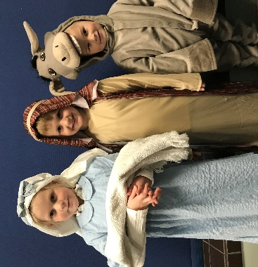
- Making pizzas at Pizza Express which we ate for our lunch!
- Developing into readers and writers
- Making Gingerbread Men
- Performing in a nativity play
- Trying lots of different vegetables at Harvest time
- Learning songs to share with our families via Seesaw
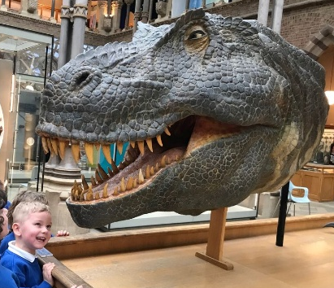
- Summer Maypole dancing
- Going to the Natural History Museum
- Singing to the residents of Bridge House Care Home
- Visiting the Story Museum in Oxford
- Finding ‘dinosaur eggs’ in our outdoor area!
- Walking to the post box to send our letters to Santa
- Visit to Waitrose to find out where food comes from
- Members of our community coming to visit to tell us about their occupations
….the list could go on and on!!

The Foundation stage curriculum and implementation
Children follow the Foundation stage curriculum and work towards Early Learning Goals (ELG.) These can be found at www.gov.uk under Development Matters. Children work towards the ‘Development Matters’ in the Early Years Foundation Stage (EYFS) focusing on three prime areas: Personal, Social and Emotional Development, Communication and Language Development and Physical Development. The further four specific areas are Literacy, Mathematics, Understanding the World and Expressive Art and Design. Throughout your child’s time in Foundation, we will use your child’s individual characteristics of learning to enhance your child’s education programme.
To ensure all children make the best possible progress, we will make initial assessments when your child first enters our setting. You will be invited to meet with me during you’re the first term to discuss how they have settled. During your child’s time in the setting, informal assessments are made by all staff which we will use to help ensure their progress towards ELG. Parents are welcome at any time to discuss their child’s progress; however, parents are offered two formal meetings per year when I will report this.
The planning is flexible and tailored to ensure that all children’s needs are catered for. Emphasis is put on the process of learning and many skills and experiences do not always have an end product. If your child does not have anything to show you at the end of the day, it does not mean that they have not been busy learning! Most of our learning is on a practical level through play activities which develop many different skills. Talking to your child about what they have been doing can really build up their confidence. When they bring work home it is important to give your child praise and value what they have produced.
During your child’s time in Reception we will be uploading photos and comments to an online platform called Seesaw. There is a consent on Arbor which must be completed to allow me to create your child an online account. Any ‘wow’ moments will be captured and uploaded for you to see. This is such a wonderful way for you to get an insight into what your child does at school as I know all too well that when children are asked what they have done at school the response can often be “I don’t know” or “Nothing!” I will also record and share photos or videos of the whole class during special events or performances.
On leaving the Reception class the ‘Foundation Stage Profile’ is completed and children’s achievement is reported to parents. This profile helps Year 1 staff plan for your child’s future learning and we work alongside the next teacher to ensure a smooth transition.
Reading Record book
When children are ready to begin reading groups, I will give your child a Reading Record book to keep a diary of the books they have read. They will bring a book home matched to their phonics ability which they can read to you, and a ‘Read Together’ book which you can read to them. The children are encouraged to enjoy stories by talking about the pictures and the characters; thinking about what is familiar in the story and how it links to their own lives and experiences. When reading to you, children are encouraged to use their ‘reading finger’ to point to the text and turn the pages as they read. The wide range of books in the classroom offers the children plenty of choice, with a variety of fiction, non-fiction, and poetry books. There will be more information about how I teach phonics and reading once your child has started school.
Things your child will need for their first day:
- School uniform – grey/black trousers or shorts or a school dress/skirt, a white polo shirt, and a royal blue jumper or cardigan. This is available from Trutex in Didcot and can be ordered online at https://myschoolwear.co.uk/
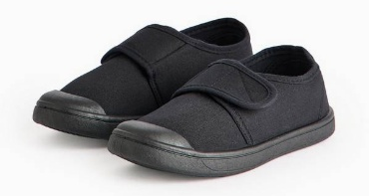
- A pair of outdoor shoes – - which they will wear to and from school and during their time outside during the school day.
- A pair of plimsolls to stay in school as their ‘indoor shoes’.
- At least one full change of clothes and extra underwear – all labelled in a small bag which can stay on their peg.
- Labelled waterproof coat
- Wellies – please label on the OUTSIDE to help us find them more easily! These can be left on the welly rack outside the cloakroom door in the Reception garden.
- Labelled sunhat – please apply sun cream before school on very hot days
- Labelled water bottle with water only please
Due to the nature of the activities that take place in foundation the children can get messy even with an apron on! When they are working with glue, paint, water, shaving foam, or mud it is important that they are not upset by any accident that may occur. We recommend always having a full change of clothes on their peg just in case. Please ensure your child’s school uniform is easy for them to manage when using the toilet. This will help them to develop their confidence and independence in this area.
On Tuesdays, the children will have PE and we ask that you send them to school in their PE kit. They need black or navy jogging bottoms/leggings or shorts with an elasticated waist and a sky blue PE T-shirt. They can wear their normal cardigan/jumper, or a hooded jumper is available from Trutex. https://myschoolwear.co.uk/
Please ensure ALL your children’s belongings are clearly labelled. We always have so many lost jumpers which are never reunited with the right child because they aren’t named.
We encourage the children to leave their toys at home as it can cause disagreements and tears if they are lost or broken. The staff cannot take responsibility for them.
We will ask for things that may support our topic during the year, and we invite visitors in to talk to the children about religious festivals or occupations, but more information will be sent out during the year.
If your child is very young and you are worried about whether they will struggle with full time attendance, please speak to the office or arrange a time to meet with me and we can discuss your child’s individual needs.
Further details about transitional visits and pre-school visits will be sent out as soon as they are finalised. We very much look forward to meeting you all soon!
Very best wishes,
Mrs Blagrove and the Reception team

